September 22, 2017 Agenda – 10:00 am
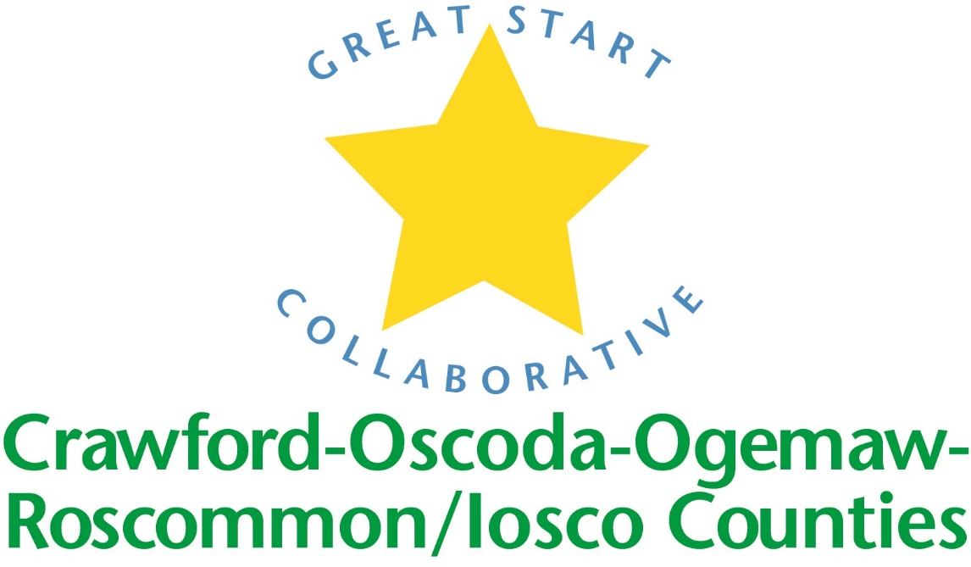

Location: Roscommon Middle School

Great Start Collaborative Meeting

For parent reps calling in:

Toll Free Number: 1 888 585 9008

Conference Room Number: 794-310-488

NORMS OF ENGAGEMENT:

● Open to other’s opinions and ideas

● Take care of your needs

● Consensus decision making

● Being respectful of each other’s time

● Everyone has a voice

● Time keeper-stay on schedule

● Keep phone muted

Call to Order

Welcome

Approval of Minutes from previous meeting
Motion by _____________________________, supported by ___________________________

4. Patti Peiffer - Michigan Special Education Mediation Program

5. Scholarships

6. Parent to Parent Connections

Trusted Advisors Grant

Early Childhood Conference-Conference Topics?

Introductions and updates – limit to 2 minutes

School Readiness Advisory Committee

Child Data

End of Year Parent Feedback Results

Literacy Nights

Parent Engagement
  - Steering Committee
  - GSC participation
  - Google Classroom

Adjournment

Next meeting: Friday, November 17th, 2017

