MINUTES
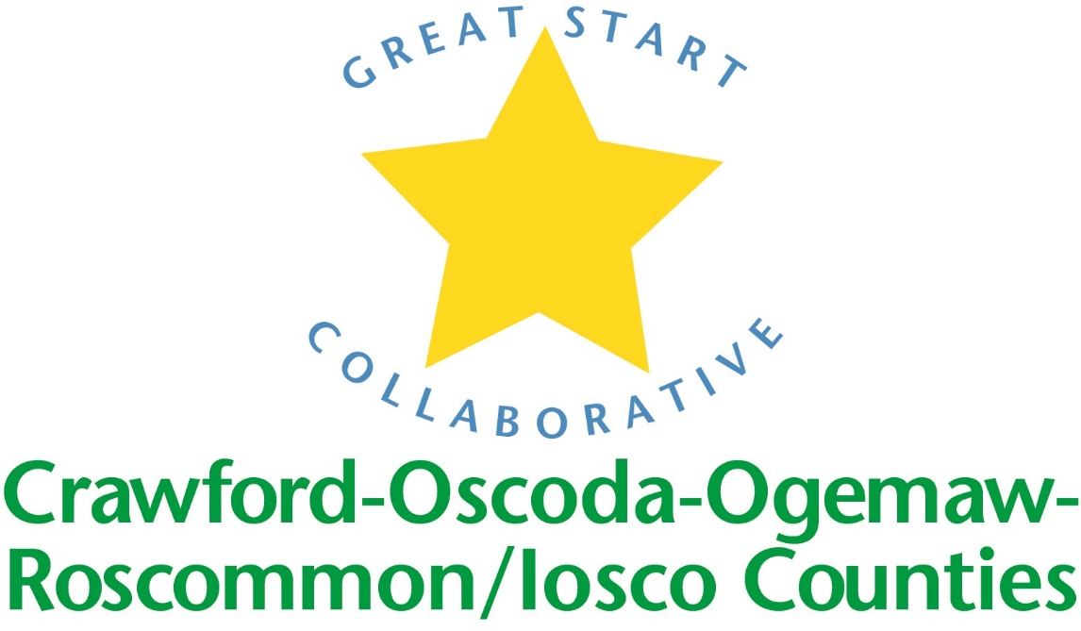

GREAT START COLLABORATIVE

ROSCOMMON MIDDLE SCHOOL

March 17th, 2017
Amy Coulter, Great Start Parent Liaison called the meeting to order at 10:05 A.M.

MEMBERS PRESENT:
Michele Cochrane, Carmen Michels, Jennifer Leach, Kristen Hamp, Ashley Lawrence, Brooke Buboe, Heather Benson, Nicole Miller, Desiree Lipski, Amber Kuhn, Tammy Tyler, Katie Keith, Shawna Jobson, Gail Hughey, Sue Browder, Elizabeth Burtis, Amy Coulter, Michelle Schepke

Phone IN Members PRESENT:
Amy Mason, Lauren Carry

Approval of MINUTES
Motion by Desiree Lipski, supported by Katie Keith to adopt the Minutes as presented.

Update on scholarship Parent Survey:
In February, all 48 families that received a scholarship were mailed a parent survey to gather data and input. 24 were returned. The majority of the families were not interested in parenting classes, but the ones that were are interested in SF and Social Emotional training. The resources that parents with young children found most beneficial are Preschools, Playgroups and Libraries. The resources that parents found lacking in their area are Preschools, Child Care, Community Centers, Activities for families during non working hours, and opportunities for over income families.

Update on Early Childhood Conference
Conference held on April 22, 2017 from 9:00-3:45 at Roscommon High School Registration is now open. Keynote address by Dr. Mark Sloane on Understanding Complex Children with Prenatal Exposure and Toxic Stress. Breakout sessions include: Overview of Collaborative Interdisciplinary Treatment in Complex Young Children, Essential Roles of School and Home Visitor Staff for Complex Young Children with Behavioral Challenges, Creating Leaders in the Infant/Toddler Classroom, Helping Children with Self Regulation, Science for Young Minds, Positive Guidance and Discipline, Enhanced Outdoor Learning, MTSS: Cooperation, Prevention and Interventions, Working with Diverse Parents in the Infant/Toddler Environment, Exploring Art for Early Learning, Healthier Childcare Environments, Story Telling and Teaching Children to Save.

Trusted Advisory Grant
Grant will be awarded to Parent Coalitions in the amount of $5000-$60,000. Purpose of grant is to increase and engage hard to reach parents in early childhood and to possible support existing programming. Still waiting on some more guidance from The Office of Great Start but it can be used for multiple projects.

MAKE UP OF GREAT START MEETING FOR FY18
For FY 18, there will be a GSC meeting held in Roscommon and then one in Tawas the following week (or within the same month). A calendar is being developed and all meetings will be held on Fridays.

KINDERGARTEN TRANSITION WEBSITE
It’s up and running. This website on livebinders was driven by the parents. Members were asked to test and play around on the website and provide feedback.
End of joint meeting

Introductions and updates:
GSTQ: An infant/toddler parent survey is being widely distributed in their 11 counties. Distributed Quarterly Report. Qualifying programs can get up to $4500 in grant money each cycle. Kaplan and Lakeshore are giving discounts and free shipping.
RCN: Shawna Jobson is opening a 0-3 Childcare Center in Roscommon in August 2017. She received a $4000 grant for playground equipment. The name of the center will be “Shay’s Play Place”. She hopes to provide care 24/7.
Collins GSRP: Preschool Round Up, April 19th from 5-7.
RAPS GSRP: Preschool Round Up, April 19th from 6-7:30
CHA GSRP: They had their enrollment fair on March 8th. Of the 20 families that were interested, there were 5 children that were age eligible.
Michigan Alliance for Families: Provides Special Education Advocacy 0-26. They are having a stakeholder survey at Roscommon Library, Tuesday May 23rd from 4-6.
Early On: Updated on the LICC Meeting Dates. The EC Roundtable is on April 28th from 10-3 at Roscommon Middle School.
Good Shepherd: Would like to collaborate with an agency to do a Saturday training of Conscious Discipline.
BRAINSTORM SUMMER PARENT ENGAGEMENT AND PARTNER WITH OTHERS
Summer Explorations at State Parks
Public Libraries
Home Visits
Encourage reading to your child
EHS has open playgroups in the summer

Adjourned at 11:11

